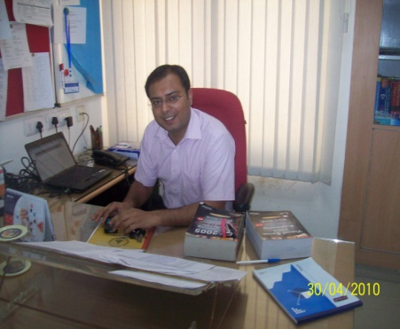ARUN SOLANKI

**Faculty/Research Associate**

School of Information and Communication Technology

Gautam Buddha University

Greater Noida , Gautam Budh Nagar

Uttar Pardesh -201308

**🖀** : 0120-2344297

E-mail: asolanki@gbu.ac.in

: ymca.arun@gmail.com

**Professional Qualification-**

* M.Tech. in Computer Science and Engg. from YMCAIE, Faridabad with 1st Division.
* M.Phill. in Physics from C.C.S. University, Meerut in 2006 with 1st Division.
* M.Sc. in Physics (Electronics) from C.C.S. University, Meerut in 2004 with 1st Division.
* B. Sc. in PCM from C.C.S. University, Meerut in year 2002 with 1st Division.
* One year HNC diploma from NIIT with A+ grade.

**Publications-**

**International Journal**

* Dr. Ela Kumar**, Arun Solanki “** A Combined Mining Approach and application in Tax Administration**”** published in International journal of Engineering and Technology ,Vol.2(2), 2010, pp,38-44.

**International Conference**

* **Arun Solanki**, Dr. Ela Kumar “Online Query Submission for deep web in specific domain” paper orally presented and published in the proceedings of 2nd International Conference on Computer Engineering and Technology (ICCET 2010) held on 16-18, April 2010, Chengdu, Sichuan, China, Vol 3, 2010, pp,31-34.

**National Conference**

* A.K. Solanki, **A.Solanki**, Sourabh Singh “Deep Web: Present and Future- A Review” paper published in proceedings of national conference ETCS-09 at MIET Meerut, U.P. India.

**Achievements-**

* I have scored GATE with AIR Ranking 348.

**Research -**

* **Title**- Domain Specific Interface Matcher.
* **Team Size**-2.
* **Technology**-ASP.NET, SQL SERVER 2005.
* **Duration**- 3 Months.

**Description-** In this project, the problem of discovering semantic correspondences between attributes of different search interfaces, but in the same domain, has been identified and a framework to discover these mappings has been successfully implemented.

There were three modules in projects-

1. Fuzzy Matcher.
2. Data Matcher.
3. Thesaurus.

The three modules were successfully implemented using asp.net as front-end and SQL Server 2005 as back-end.

Responsibilities-

* Coded Entire Process Module.
* Involved in the understanding the application, Designing and coding.
* Involved in creating database tables.
* Participating in weekend reviews with team members.
* Involved in designing the pages.
* Developed the application logic and implementation.

**Dissertation (M.Tech.)-**

**“Online Query Submission of Deep Web for Specific Domains”**

There are two types of web- Surface Web & Deep Web. Surface Web is crawled by a general purpose search engine like- Google, Yahoo etc. Deep Web is the area of the WWW which is hidden from general purpose search engine. Hence the information is not retrieved by general purpose search engine. In this dissertation work I built unified interfaces for different domains like books, movies, electronics etc. A query is passed through this unified interface and we find the result of high accuracy for different domains.

SQL Server 2005 is using as back-end and asp.net as front-end.

**Dissertation (M.Phill.) –**

**“Vibrational Spectroscopic Study of Ascorbic Acid”**

Our body requires Ascorbic acid (known as vitamin C) to maintain its proper function. It is an organic acid with antioxidant properties. Vitamin C is very important in healing of wounds and broken bones.

The IR and Raman Spectra of ascorbic acid have been recorded in solid phase. The observed frequency have been assigned to different modes on the basis of their magnitude and relative intensities. The result was satisfactory because most of the modes appear in the expected ranges suggested in literature.

**Teaching Experience-**

* Part time faculty in YMCAIE Faridabad from Sep 06-May 08.
* Visiting Faculty at MAIT Rohini, Delhi from Aug 08-Dec 08.
* Lecturer at MIT Meerut from jan-09-Oct 09.
* Faculty/Research Associate at Gautam Buddha University Greater Noida Nov-09 to till date.

**Professional Affiliations-**

* Life Time Member of ISTE (Indian Society of Technical Education).

.